**Gracious Germents**

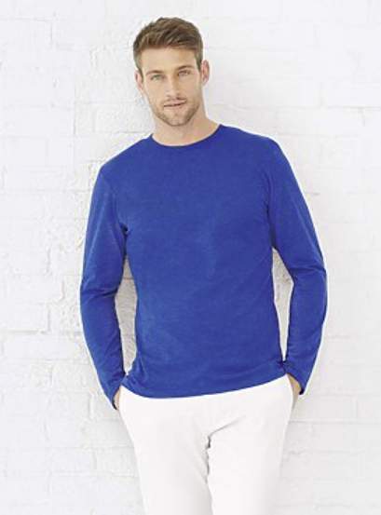

**DESCRIPTION:**

Code Five™ Adult 100% Combed Ringspun Cotton Fashion Camouflage Crew Neck Short Sleeve Tee

Add a little streetwear flare with the fashion camo tee. Woodland camo colorblocked with a solid jersey body and a fashion pop in the back necktape, this style is fresh and trendy and is the perfect streetwear spin on traditional camo.

Fabrication: 4.5 oz. 100% combed ringspun cotton printed camouflage jersey

Features: Contrast topstitched ribbed collar • Contrast self-fabric back neck tape • Coverstitched double needle hem sleeves and bottom hem • Flatlock stitched side seams • Side seam construction • EasyTear™ label

Care: Machine washable/ tumble dry low

Note: Bleed resistant ink is recommended when printing our camouflage products

Fit: Adult Unisex – True to Size

2% of all Code Five™ sales are donated to Children of Fallen Soldiers Relief Fund, Inc. and Fisher House™.

**ADDITIONAL INFORMATION**

Weight: 0.5 kg

Dimensions: 10 × 8 × 3 cm

Size: S, M, L, XL,

Price: $31.00